Application for C-TPAT Membership
(Note: This page is for reference only. Application must be made online. See procedure for link)
Business Type : | *
Legal Name : | *
Doing Business As :
Ownership Type : | *
Years In Business :
Number Of Employees :
Country/Territory : | 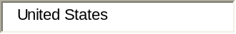 *
Physical Street Address : | *
City : | 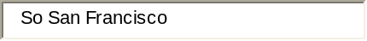 *
State or Province : | 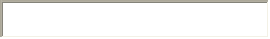 *
Zip Code or Postal Code : | 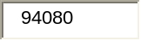 *
Mailing Country/Territory : | 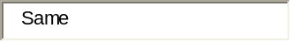
Mailing Address :
Mailing City : | 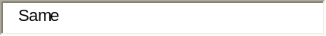
Mailing State or Province : | 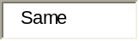
Mailing Zip Code or Postal Code :
Company Direct Phone Number : | 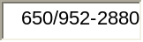 *
Fax Number : | 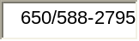
Contact First Name : | 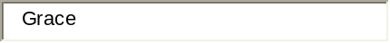 *
Contact Last Name : | 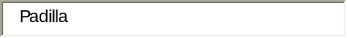 *
Title : | 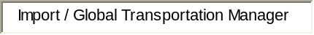 *
Company Point of Contact Direct Phone Number : | 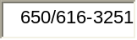 *
Contact E-mail Address : | *

Retype Your E-mail Address : | *
Business Type : | Importer
Legal Name : | Sanrio Inc.
US-issued importer of record (IOR) number : | 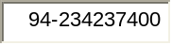 * Select format IOR number :
  Must be 9 characters or more and select format IOR number.
Additional (IOR) number(s): | Separate IOR number(s) with a comma.
CBP Importer Bond Number : | 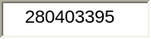 *

Required Documentation: Importer - C-TPAT Agreement to Voluntarily Participate
This Agreement is made between Sanrio Inc. (hereinafter referred to as "the Importer") and U.S. Customs and Border Protection (hereinafter referred to as "CBP") to participate in the Customs-Trade Partnership Against Terrorism (C-TPAT), a voluntary and cooperative partnership established to achieve the goals of building more secure and more efficient borders.
This Agreement between the Importer and CBP is intended to enhance the joint efforts of the Importer and CBP to protect the supply chain, identify security gaps, and implement specific security measures and best practices
Specifically, the Importer agrees to:
- Conduct a comprehensive assessment of the Importer’s global supply chain(s) based upon established C-TPAT security criteria to include: Business Partner Requirements, Cargo Security, Container Security, Physical Access Controls, Personnel Security, Procedural Security, Security Training/Threat Awareness, Physical Security, and Information Technology Security. The supply chain is defined from point of origin (manufacturer/supplier/vendor) to point of distribution.
- Develop a written and verifiable process for determining risk throughout the Importer’s global supply chain(s) based upon the Importer’s business model (e.g., volume, country of origin, routing, potential terrorist threat, etc.)
- Implement and maintain appropriate security measures throughout the Importer’s global supply chain(s) in a written and verifiable format that is consistent with C-TPAT security criteria and based upon risk analysis as determined by the Importer’s business model.
- Complete and upload the Importer’s Supply Chain Security Profile document.
- Develop and implement a written and verifiable process for the selection of all business partners in the Importer’s global supply chain(s) including manufacturers, product suppliers, and vendors based upon C-TPAT security criteria regarding Business Partner Requirements. Where the Importer out- sources or contracts elements of their supply chain(s), the Importer must ensure that appropriate security measures are in place, effective, and complied with.
- Develop and implement a periodic Self-Assessment Program in a written and verifiable format to ensure that appropriate security measures consistent with C-TPAT security criteria are maintained and are sufficient throughout the Importer’s global supply chain(s), and implement changes as necessary or needs arise.

- Notify CBP at industry.partnership@dhs.gov of all changes and/or modifications to the Importer’s information on file including Official Company Name, Street Address, Company Point of Contact, Telephone Number, Fax Number, and E-Mail.

Upon acceptance, review, and/or certification in the C-TPAT, CBP will:
- Provide feedback and guidance to the Importer on the information provided in the Supply Chain Security Profile within 60 days of receipt.
- Provide technical assistance and recommendations to the Importer to improve the Importer’s supply chain(s) pursuant to C-TPAT security criteria.
- Provide incentives and benefits to include expedited processing of C-TPAT shipments.
- Assign a C-TPAT supply chain specialist to serve as the CBP liaison for validations, security issues, procedural updates, communication, and training.
- Ensure all information provided by the Importer to CBP will remain confidential. CBP will not disclose the Importer's identity as a C-TPAT partner without the Importer's consent.

This Agreement will be administered pursuant to a plan jointly developed by CBP and the Importer.
This Agreement is subject to review and acceptance by CBP and the Importer and may be terminated upon written notice by either party.
This Agreement cannot, by law, exempt the Importer from any statutory or regulatory sanctions in the event that discrepancies are discovered during a physical examination of cargo or the review of documents associated with the Importer's transactions with CBP.
This Agreement does not relieve the Importer of any responsibilities with respect to United States law, including CBP regulations.
Ken Yamamoto
Sr. Vice-President
Sept 11, 2006

